Project Initialization and Planning Phase

Date | 26 June 2026
Team ID | xxxxxx
Project Name | Personalized Networking Assistant
Maximum Marks | 3 Marks

Define Problem Statements (Customer Problem Statement Template):



Create a problem statement to understand your customer's point of view. The Customers Problem Statement template helps you focus on what matters to create experiences people will love. A well-articulated customer problem statement allows you and your team to find the ideal solution for your customers' challenges. Throughout the process, you’ll also be able to empathize with your customers, which helps you better understand how they perceive your product or service.

Example:
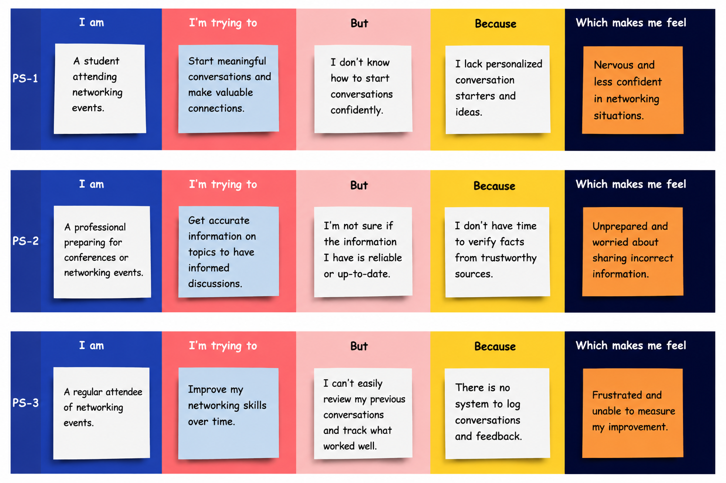

Problem  Statement  (PS) | I am (Customer) | I’m trying  to | But | Because | Which makes me feel
PS-1 | A student attending a networking event. | Start meaningful conversations with professionals and peers. | I don't know how to begin conversations confidently. | I have limited networking experience and lack suitable conversation starters. | Nervous and less confident about interacting with others.
PS-2 | A professional attending conferences and seminars. | Prepare for discussions on event-related topics. | I am unsure whether the information I have is accurate. | I don't have enough time to verify facts from reliable sources. | Unprepared and worried about sharing incorrect information.
PS-3 | A user who regularly attends networking events. | Frustrated and unable to measure my improven | I cannot easily review my previous conversations or identify what worked well. | There is no organized way to track my conversation history and feedback. | Frustrated and unable to measure my improvem

